Marjorie Mann
Lawley Daycare Centre

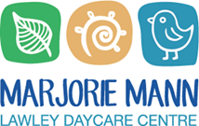
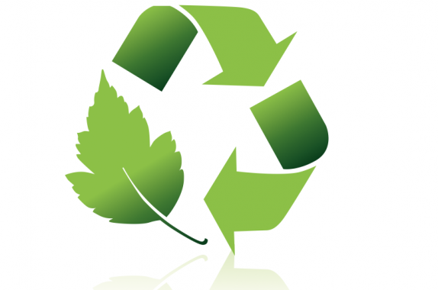
Sustainability Action Plan
2021-2024
What Does Sustainability Mean to Us?
For some of our staff members, Sustainability is a topic they are already very passionate about. They are motivated to save the planet, leaving it in a good condition for future generations and animals. They are inspired to reflect on their waste management approaches, mindful use of natural resources and teaching strategies to pass this knowledge along to others, both children and adults. For other colleagues, they are still developing their understanding of what sustainability means and how we can apply what we have learned to our own lives and our professional work with children. These questions guide our current thinking and reflective practice:
- How do we develop our understanding of how our choices everyday impact our environment, our world?
- How can I avoid creating unnecessary waste?
- How often do I have to buy new things? Do I need it?
- What is the best way to recycle my waste?
- How can I encourage staff members who are still at the beginning of the journey with sustainability, empowering them to be an active participant?

What Do We Want to Achieve in our Sustainability Program?

- Guide children in learning about environmental responsibility, developing a sense of care, wonder and appreciation for the world around them.
- Educate children and families in sustainability practices with the hope that they may become positive agents for change, spreading the excitement and knowledge to future generations.
- All Staff Members have a basic working knowledge of what our Centre is doing to be more sustainable and environmentally conscious.
- To make the most of community partnerships to extend our knowledge of how we can be more sustainable.
- To share information with our community along the way in our sustainability journey, leading to learning for others.

What Opportunities Do We Have to Move Forward in our Journey?

- Collaborate with staff members and families to learn more about the recycling options available in our local community.
- Give unwanted toys or furniture a second life by donating to charity, sharing with others via our local Buy Nothing Facebook group or advertising items for sale on Gumtree
- Continue conversations about the small choice that can make a big impact on our world; these conversations are important with both children and with adults.

Links to the National Quality Standard

Quality Area 1.2.1: Intentional Teaching- Educators are deliberate, purposeful and thoughtful in their decisions and actions.
Quality Area 3.2.3: Environmentally Responsible- The service cares for the environment and supports children to become environmentally responsible.
Quality Area 6.2.3: Community Engagement- The service builds relationships and engages with its community.
Quality Area 7.1.1: Service Philosophy and Purpose- A statement of philosophy guides all aspects of the service’s operations.

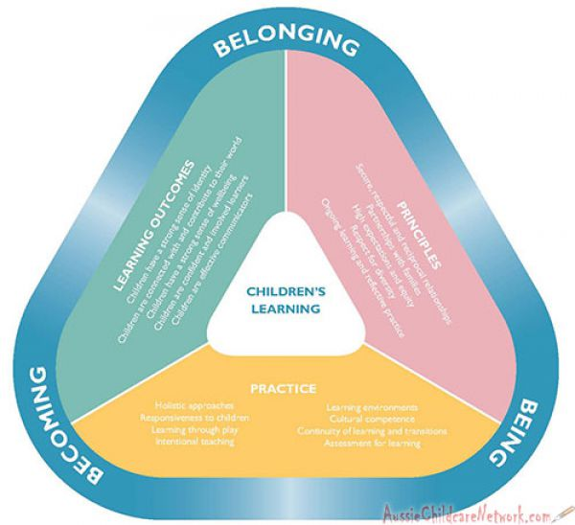
Opportunities for Learning:
Links to the Early Years Learning Framework

Outcome 1: Children have a Strong Sense of Identity
- Children develop their emerging autonomy, inter-dependence, resilience and sense of agency
- Children develop knowledgeable and confident self-identities
Outcome 2: Children are Connected with and Contribute to their World.
- Children develop a sense of belonging to groups and communities and an understanding of the reciprocal rights and responsibilities for active community participation.
- Children become socially responsible and show respect for the environment.
Outcome 3: Children have a Strong Sense of Wellbeing
- Children become strong in their social and emotional wellbeing
- Children take increasing responsibility for their own health and physical wellbeing
Outcome 4: Children Are Confident and Involved Learners
- Children develop dispositions for learning such as curiosity, cooperation, confidence, creativity, commitment, enthusiasm, persistence, imagination, and reflexivity.
- Children develop a range of skills and processes such as problem solving, inquiry, experimentation, hypothesising, researching and investigating.

In The Learning Spaces
How we incorporate sustainability in our educational program in partnership with children
- Yellow recycling bins for paper, glass, plastic containers and tins
- Red Cycle soft plastic boxes in Recycling area, staff room, Kindy 2& 1
- Lights off when leaving room
- Herb garden in all the garden areas
- Art work on recycled paper
- Water “night plants” with children’s unused water at the end of each day.
- Removing plastic bags in rubbish bins and using newspaper and retrieved paper from recycle bin. (Babies)
- Removing plastic bags for wet clothes and having parents provide wet bags.
- Parents to provide own sheets for children and send home for washing.

Centre-wide Approaches
How we incorporate sustainability into our daily work
- Collecting food scraps for Compost bin and the compost bin in the Community Garden Inglewood/ Mt. Lawley
- Newsletters and other parent information emailed instead of on paper
- Staff payslips and rosters emailed
- Recycling boxes available for parents to use
- All scrap paper given to room for art
- The unwanted drawings or carton boxes (without glue and glitter) children can rip for the worm farms and compost bins
- Ink cartridges, batteries, ring pulls recycled, light bulbs
- Terra-cycle we have for the centre a toothbrush, empty toothpaste tubes, dental floss containers etc. & razor blades
- Terra-cycle old pens, textas, markers, pencils
- Books about sustainability topics appropriate for different age groups (gardening, worms)
- Second Compost for the Kindy Garden Area
- Changing our recycling bin for paper to a bin which also includes glass, plastic milk bottles and cans etc. (items families usually put in their yellow bin at home) (achieved November 2021)

Our Current Goals

Short-Term Goals for Sustainability
- Bringing in an expert to put on a Workshop for our Staff to resource our learning
- Build a relationship with the local Beaufort Street shop, Eco Revolution, to recycle our bread tags and bottle tops.
- Finding a way to buy loose apples
- Discuss if wipes, which breaks down would be a better option for the Centre and the planet
- Replace all taps with push/stop to have a limited time they run to avoid excess water use

Long-Term Goals for Sustainability
- Install hand dryers in the Kindy 1 bathroom (saving paper)
- Install solar panels for the Service (achieved 23.12.2021)
- Guiding children to develop a sense of empathy for Nature.
- Provide an information brochure about recycling opportunities in Perth
- Establish our herb garden to service our kitchen
